 | 12.1.16 Editors - Geometry Nodes Editor - Header - Add Menu - Output
Table of content
Detailed table of content 1
Add menu - Output 1
Viewer 2

Detailed table of content
Detailed table of content
Detailed table of content 1
Add menu - Output 1
Viewer 1
Inputs 1
Geometry 1

Add menu - Output

Here you find nodes that outputs data.

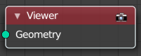
Viewer
This node allows you to output the geometry data of a node in the node tree to the spreadsheet editor.

Inputs

Geometry
Standard geometry input.

